* 1. **Creating a Table:** 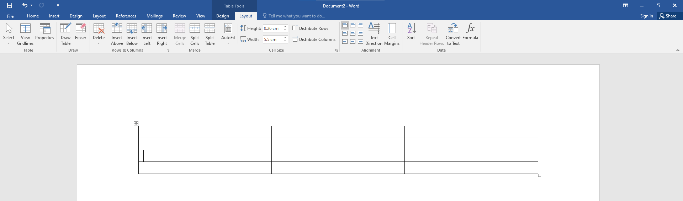
  2. **Inserting Rows and Columns in a Table**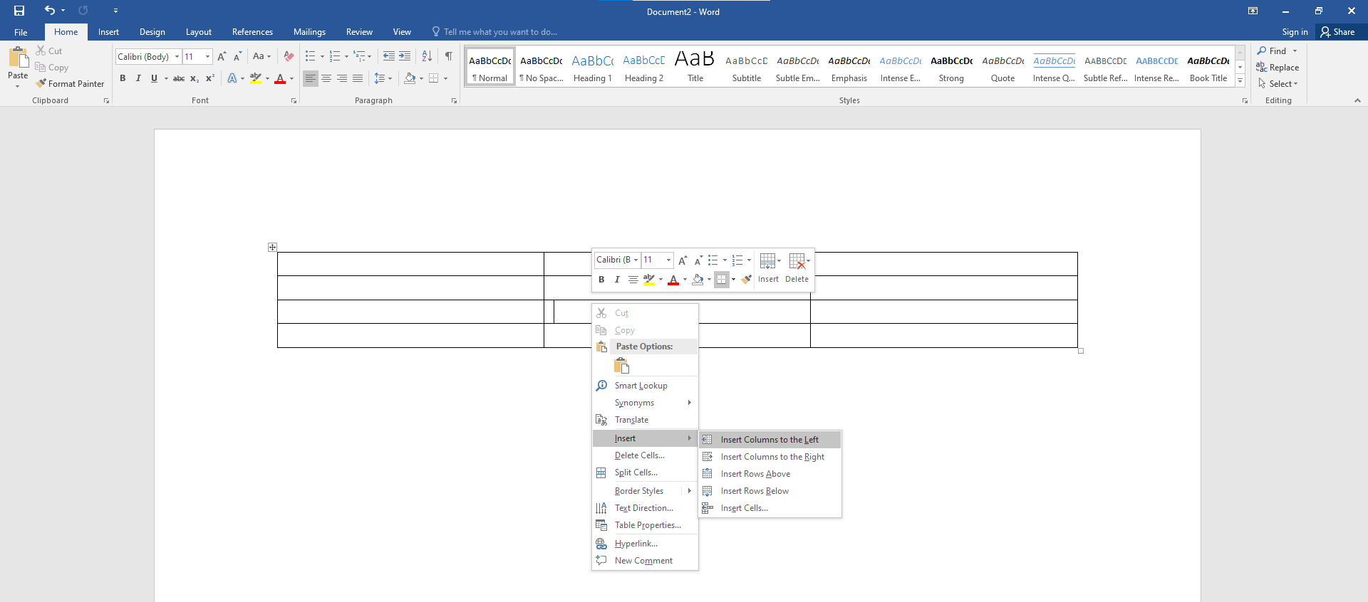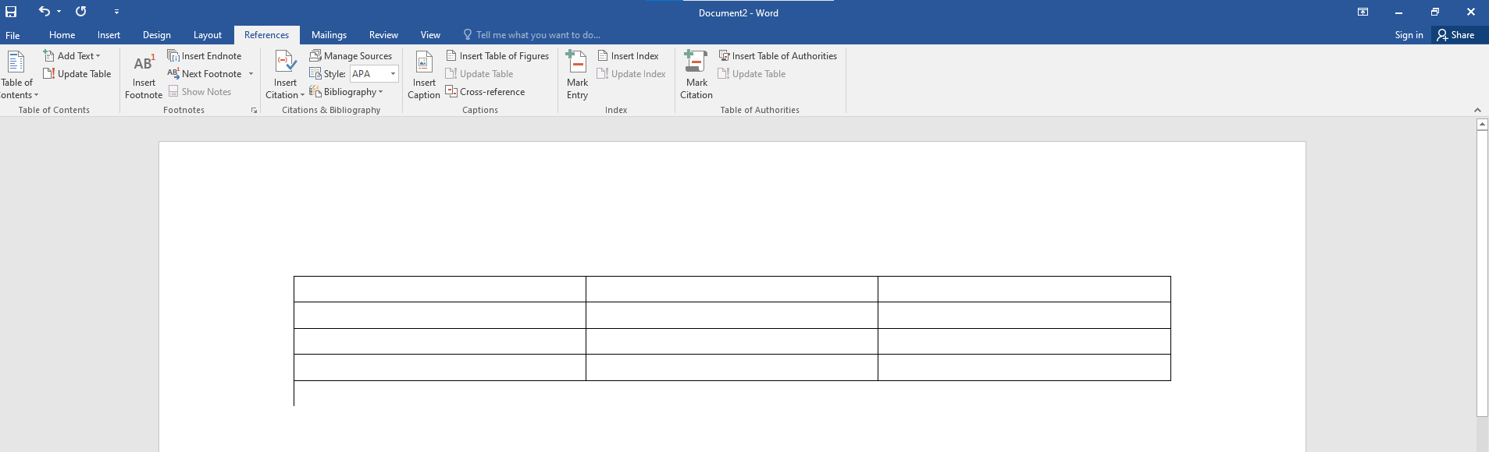
  3. **Deleting Rows and Columns of a Table**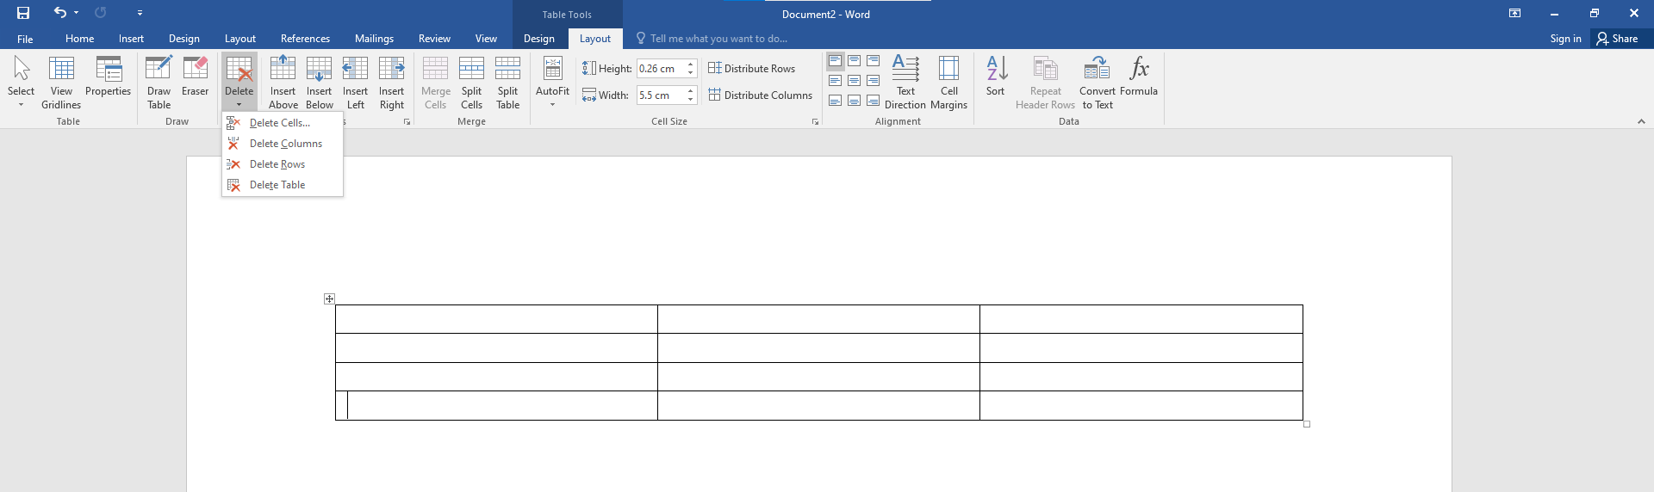
  4. **Merging cell**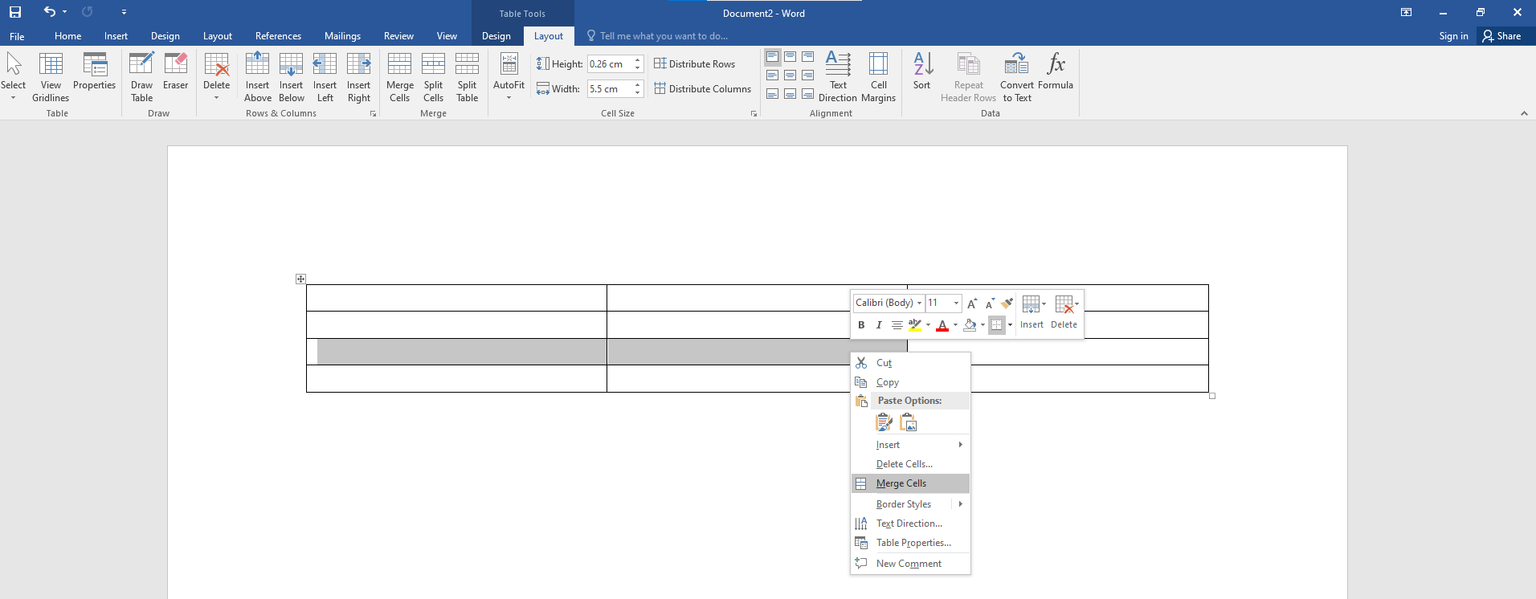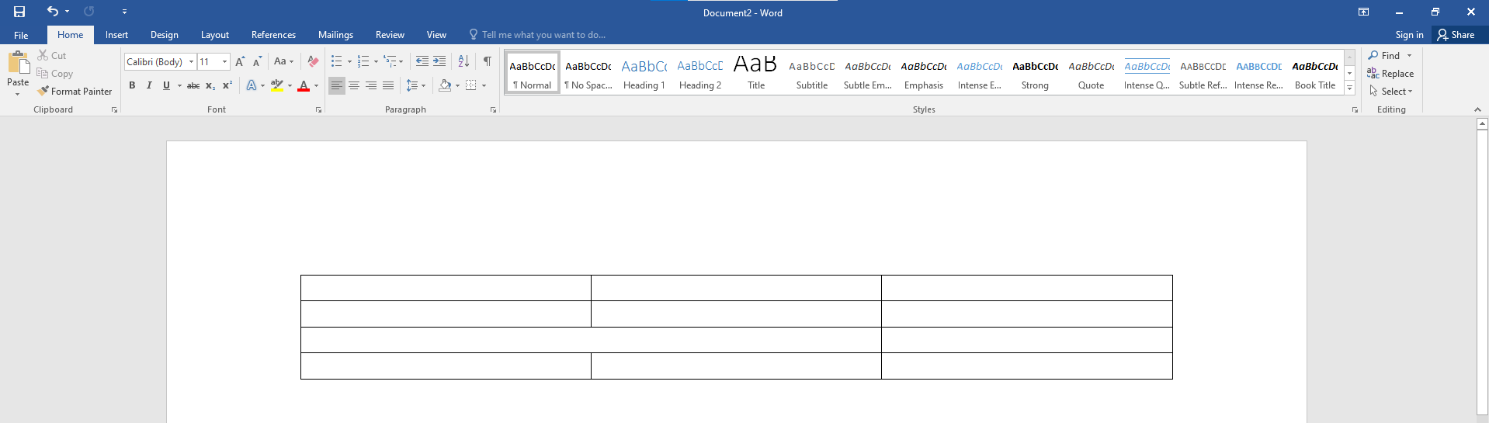
  5. **Splitting Cells**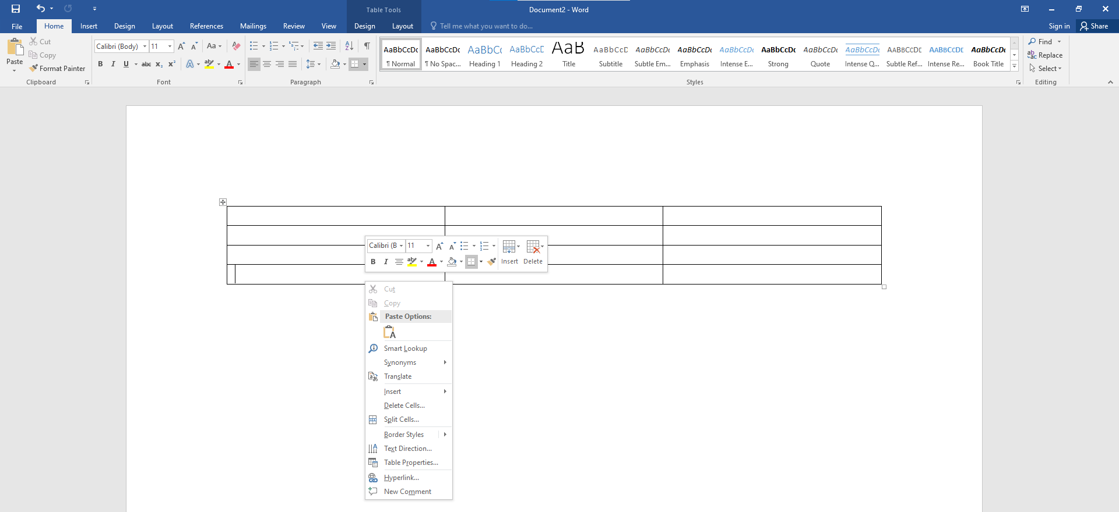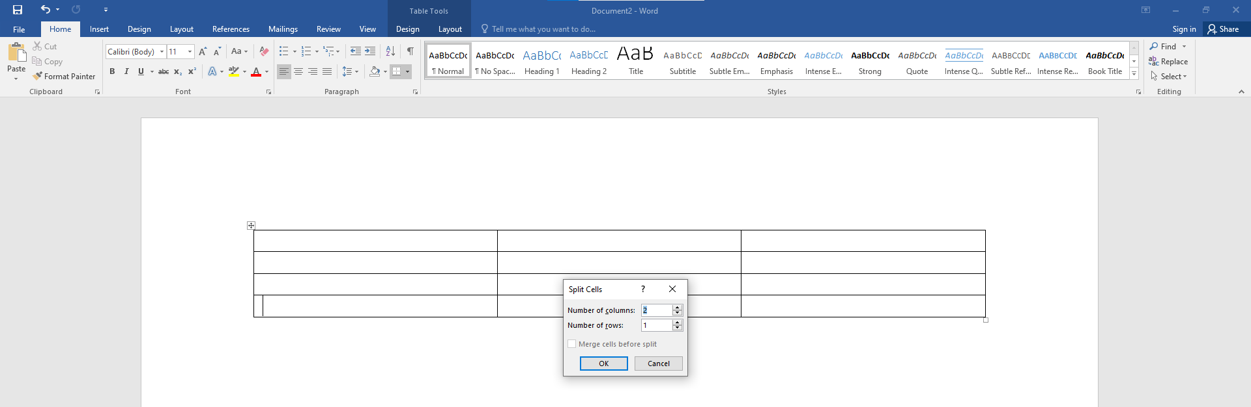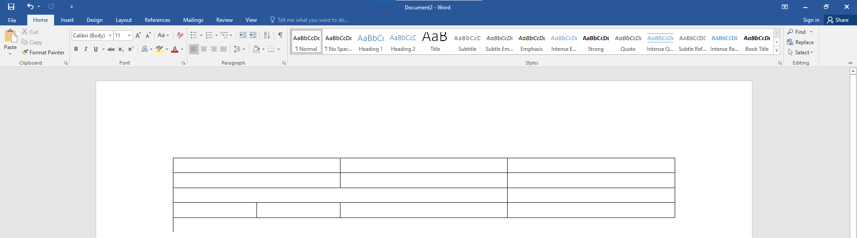
  6. **Changing Direction of Text in a Cell**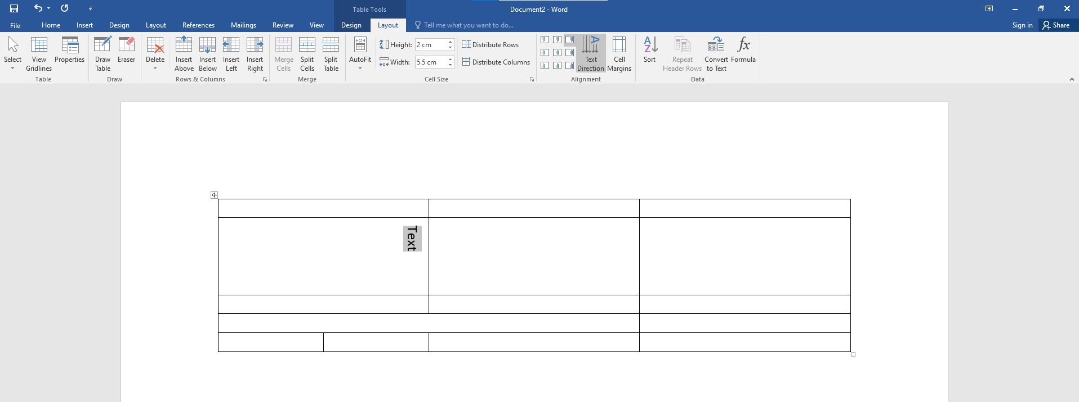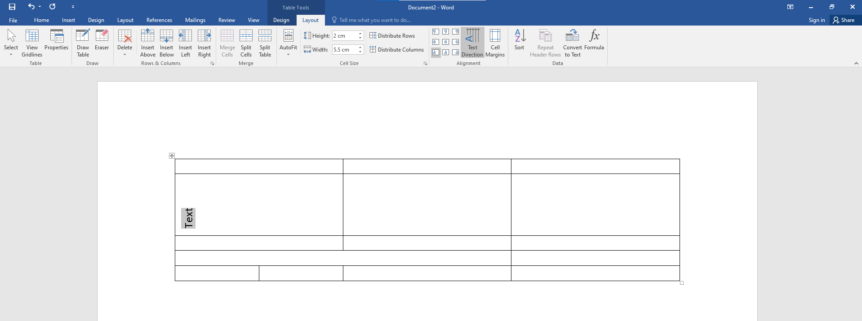
  7. **Apply Shading to Cells, Rows, and Columns**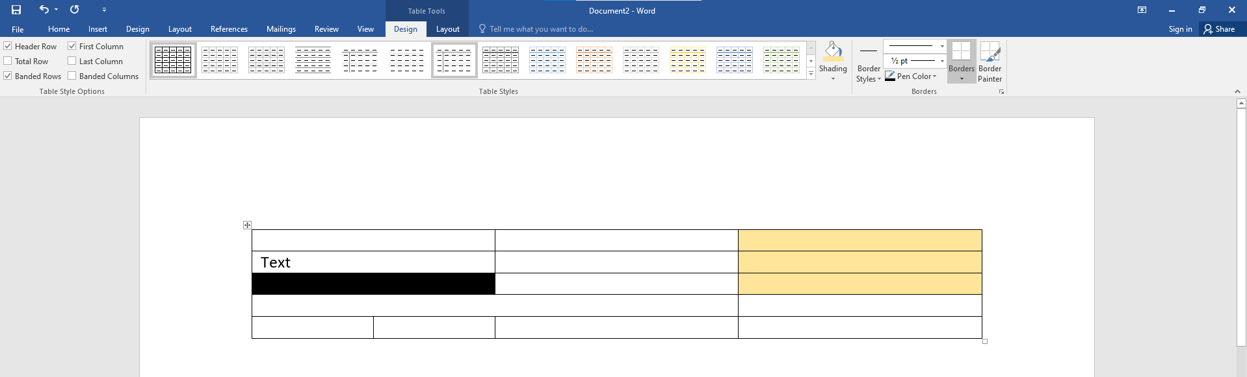
  8. **Apply Borders to Cells, Rows, and Columns**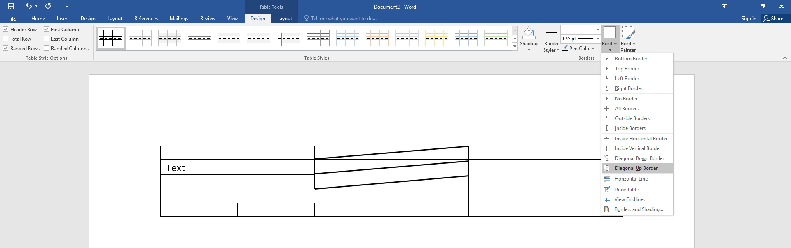

1. **Apply Borders to a Paragraph**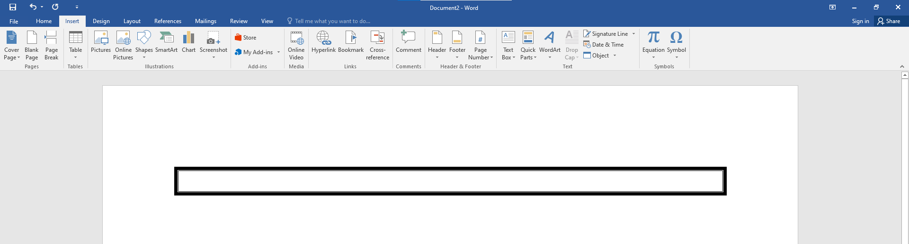

**3. Insert headers and footers and page numbers**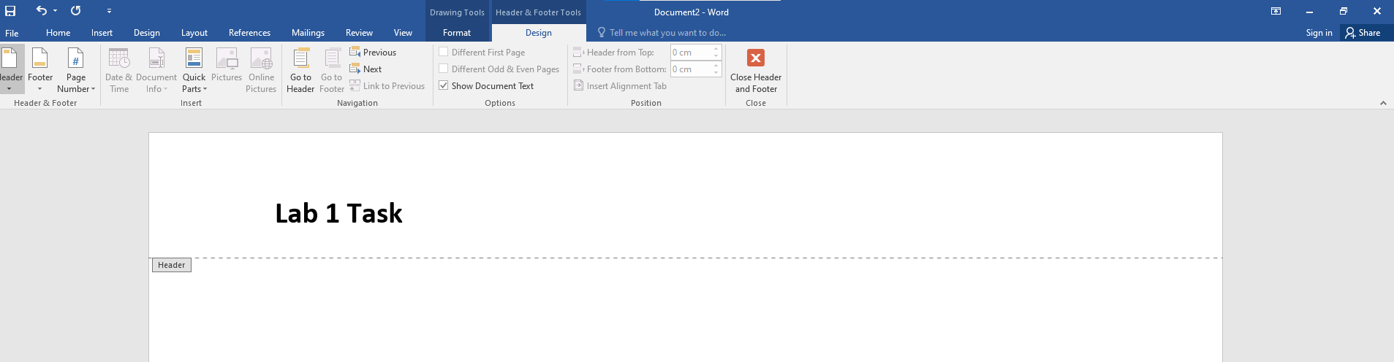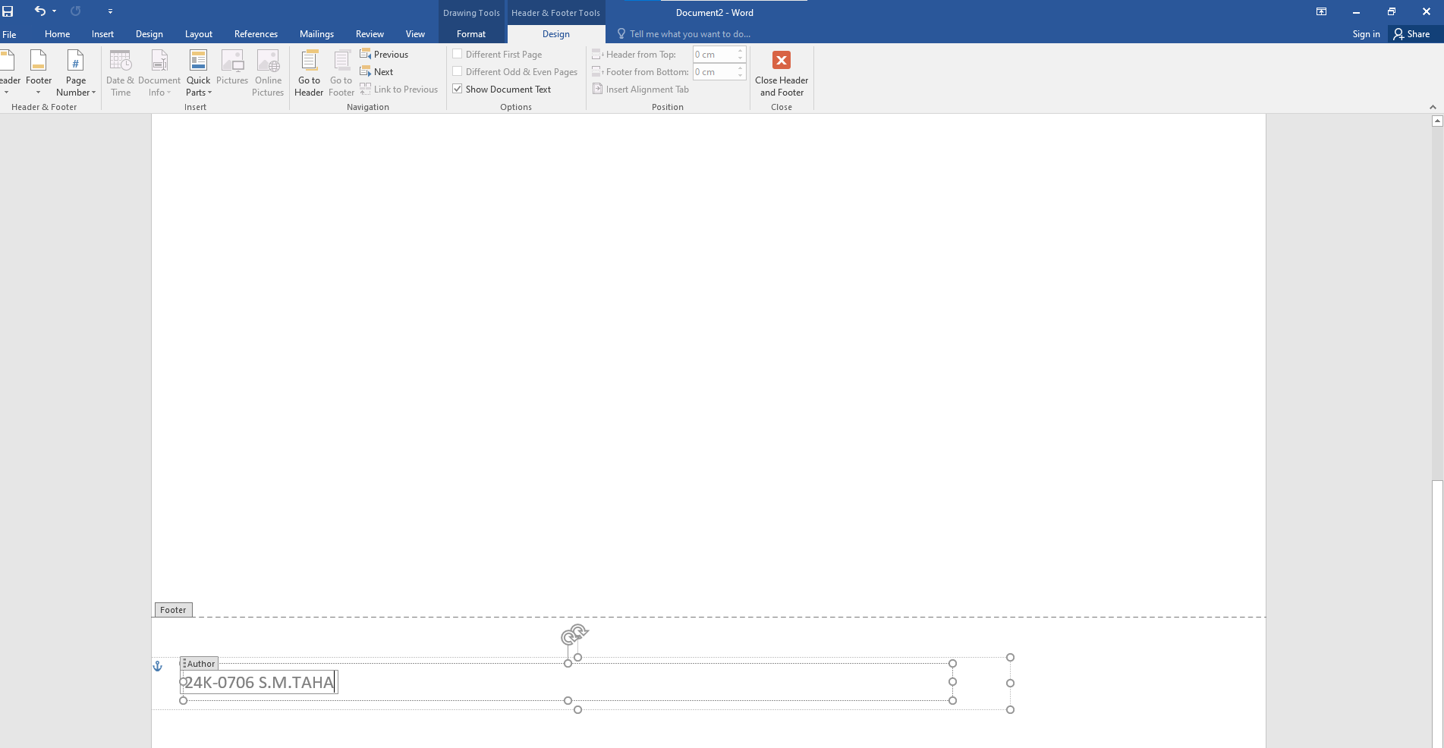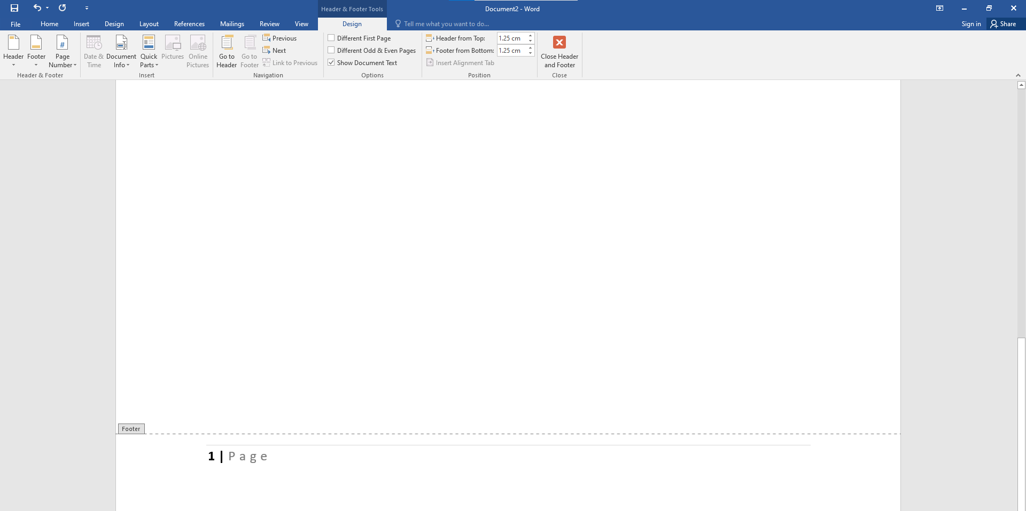

**4. Inserting Symbols**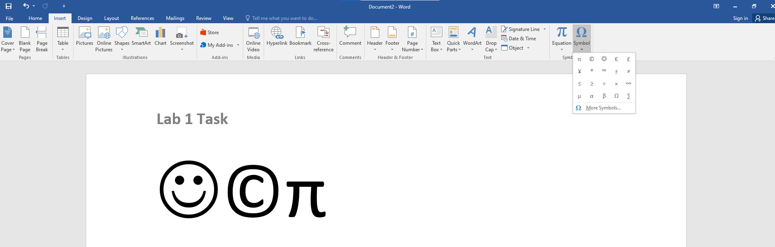

**5. Inserting Equations**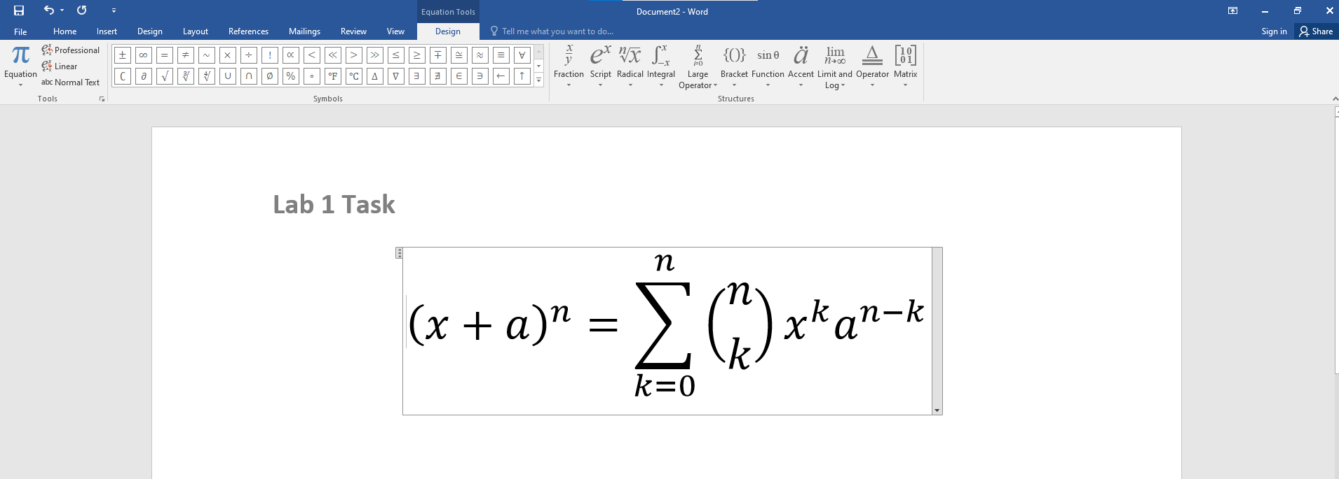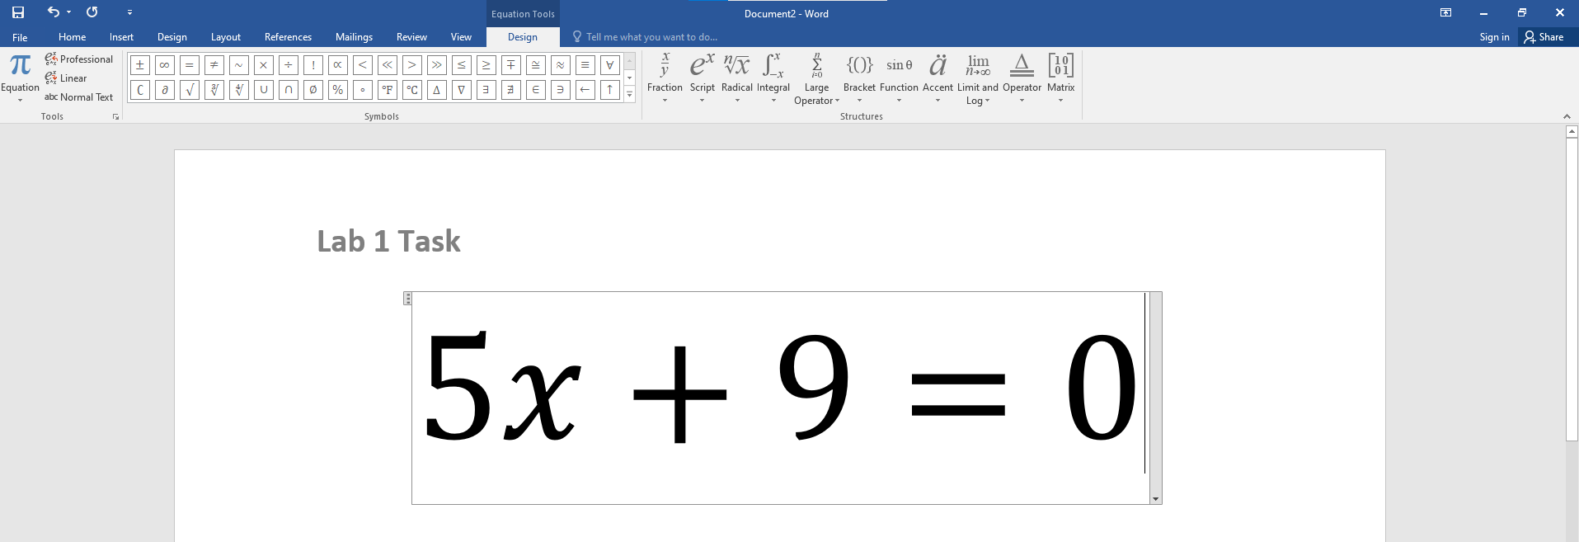

**6. Adding Image**



**7. Inserting Bullets and Numbering**

